EXHIBIT 6.4.g
Budgets for College of Education/SCH compared to Southeastern Colleges Source: Budget Request; Instituttional Research Files
Fiscal Year 2011-2012
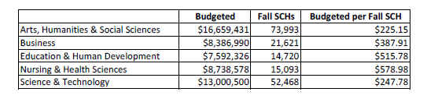
Fiscal Year 2012-2013
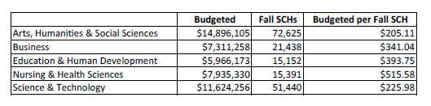
Fiscal Year 2013-2014
