Program Advisory Council File
Contents Below :
Advisory Council Member List
Meeting Minutes
Meeting Agendas

Advisory Council to Programs
2013-2014
Name | Parish | Site | Expertise
Noelle Bordelon | Tangipahoa | LAB School | Elementary
Vicki Blackwell | Tangipahoa | Central Office | Technology, Librarians
Rob Carlisle | Regional | Child Advocacy Services | Social Services - CASA
Jeannie Ebey | Livingston | Central Office | SPED
Amanda Mayeaux | Acension /Iberville | Instructional Coach | Middle School, Mathematics
Mary Jones | Washington | Central Office | Curriculum
Dr. Lou Schultz | Tangipahoa | Retired | Mathematics
Bridget Smolcich | St.Tammany | Literacy Grant | Early Literacy, Elementary
Lauren Spencer | St. Tammany | Retired | Principal - Elementary
Susan Spring | Regional | Regina Coeli Child Development Center | Head Start
Tracey Howes | St.Charles Parish | Central Office | Secondary, Grants

Program Advisory Council
Department of Teaching & Learning
Meeting Minutes

May 19, 2014
Present: | Cynthia Elliott, Wendy Jacocks, Gwen Autin, Paige Schulte, Susan Spring, Amanda Mayeau, Tracey Howes
Next meeting: | Fall 2014

- Welcome Dr. Elliott welcomed the group and apologized for the lateness of the meeting due to Spring test dates, “snow days” and other challenges to schedule the meeting. She expressed appreciation of having a close working relationship with local school districts and highlighted some of the contributions of each community/district partner and their expertise.

- Board Members were asked to introduce themselves as well as faculty roles and responsibilities.

- Dr. Elliott provided a department update on the recent local and state awards for Stewards of Children – Darkness to Light training provided to over 1000 teacher candidates since Fall 2012.

- Information was shared about the upcoming NCATE Visit with the following details:
Middle of October we will publish Invitation for third-party testimony - advisory council may wish to respond
Site Visit April 19-21, 2015
Poster session and reception for Board of Examiners, Sunday, April 19, 2015 - advisory council will be invited April 20/21, 2015 may be asked to participate in meeting with BOE either at Southeastern or your school

- Round table Tracey Howes gave an update on the Apprenticeship Program and grant funding from the state department. Susan Spring congratulated the Dept. on providing the ACT 3 Early Childhood Symposium for the region and discussed the successful collaboration and support to early care centers in this area.

- Dr. Elliott requested any feedback on programs and operations of the unit and university. Amanda Mayeaux discussed the c oncern with admissions and difficulty with new graduate student enrollments she was aware of. A follow-up was planned by Dr. Elliott to share with the DAC.

- Conclusion

Dr. Elliott thanked the members for being on the Advisory Program Council and indicated the next meeting would be Fall 2014.

Advisory Council to Programs
2012-2013
Name | Parish | Site | Expertise
Angela Bezue * | Tangipahoa | LAB School | Elementary
Vicki Blackwell * | Tangipahoa | Central Office | Technology, Librarians
Rob Carlisle | Regional | Child Advocacy Services | Social Service
Jeannie Ebey * | Livingston | Central Office | SPED
Diane Malison-Hardin | Central School District | Central Office | Curriculum
Amanda Mayeaux * | Acension /Iberville | Instructional Coach | Middle School, Mathematics
Mary Jones * | Washington | Central Office | Curriculum
Dr. Lou Schultz | Tangipahoa | Retired | Mathematics
Bridget Smolcich * | St.Tammany | Literacy Grant | Early Literacy, Elementary
Lauren Spencer | St. Tammany | Retired | Principal - Elementary
Susan Spring * | Regional | Regina Coeli Child Development Center | Head Start
Jason Medaire | St.Charles | Destrahan High School | Secondary Alt

Program Advisory Council
Department of Teaching & Learning
Meeting Minutes

March 21, 2013
Present: | Angela Bezue, Bridget Smolich, Camille Yates, Charlotte Humphries, Cynthia Elliott, Colleen Klein-Ezell, Elizabeth Wadlington, Gwen Autin, Jeanne Ebey, John Trowbridge, Lou Schultz, Mary Jones, Michelle Brown, Paige Schulte, Susan Spring, Terri Miller-Drufner, Vickie Blackwell, Wendy Jacocks, Amanda Mayeau (Via conference call)
Next meeting: | Fall, 2013

- Welcome Dr. Elliott welcomed the group and explained the focus of the council is to give feedback to the Department of Teaching and Learning. She expressed appreciation of having a close working relationship with local school districts and the opportunity to learn from all the expertise in the districts. The Program Advisory Council also helps the Department of Teaching & Learning with SACS accreditation and NCATE certification, which will be spring of 2015. Purpose of the council is collaboration between school districts and community. Dr. Elliott announced the council would meet annually.

- New initiatives in the department this semester are AVATAR Project with the University of Central Florida and a research component from the Gates Foundation. Other initiatives include curriculum training through Darkness to Light Training, sexual abuse on children for all teacher candidates in the department, Circle Literacy Grants in St. Tammany and Washington Parishes, and Library of Congress Grant.

- Community Board Members were asked to introduce themselves: Vickie Blackwell, Tangipahoa; Jeanne Ebey, Livingston; Mary Jones, Washington; Lou Schultz, retired Mathematics Department; Bridget Smolcich, St. Tammany Parish.

Teaching & Learning staff introduced were: Gwen Autin, Graduate Coordinator; Colleen Klein-Ezell, Camille Yates, Wendy Jacocks, John Trowbridge, Paige Schulte and Elizabeth Wadlington. Secondary Program partners college liaisons were English, Michelle Brown; Charlotte Humpheries, Kinesiololgy;

- Round table Vickie Blackwell reported that Tangipahoa Parish School District is work with SLU pre-service teachers for in-service with Smart Board technology training, have student teachers in their classrooms, participate in Library of Congress summer workshops and involved in the STEM Project .

Jeanne Ebey, Special Education for Livingston Parish reported her district is dealing with RTI, Compass for just a few things. She elaborated on how test scores make things really personal between students and testing. Livingston Parish is implementing digital textbooks but the cost of this technology is very expensive. Dr. Elliott suggested there might be a grant opportunity to work with the districts for digital books. Dr. Yates reported SLU had an additional 50 student teachers than prior semesters, creating a need for additional mentor teachers in districts. She also confirmed that mentor teachers must take a class for student teachers and have on-going support by the university; this is under the direction of Dr. Gail McMillion.

Dr. Lou Schultz expressed the importance of methods classes for teacher candidates as a component that is missing from other teacher certifications. This is a very critical aspect to make a teacher successful in the classroom. Dr. Elliott added how SLU has always had a good reputation for training student teachers and preparing them for the real world situation of the classroom.

Mrs. Bridget of St. Tammany Parish announced her district’s association with the Literacy Grant and how much activity is being done by teachers on their iPads, such as DIBELS and lessons plans. She also mentioned the issue of “running record” and the lack of knowledge of new teachers in the running records. A professional development training was suggested by Dr. Yates to ensure the understanding of running record and could be used for Differential Instruction in the classroom.

Amanda Mayeau, via conference call, said Iberville Parish was awarded 6 million dollars for technology but money to purchase iPads is not good without teachers being trained to use technology in classroom. She expressed even a 45-90 minute training is helpful for teachers to effectively use the iPads in the classrooms. This then allows students to be independent in learning with this technology.

Mary Jones, Washington Parish, stated another problem is students getting a general studies degree and then getting certified to teach by LRCE and Teach for America are not getting pedagogic needed to be a successful teacher. Also the Teacher of America not getting trained in methods before entering the classroom. However, alternate routes are being supported politically in Louisiana.

- Conclusion

Dr. Elliott thanked the members for attending and asked for everyone to stay in-touch and the next meeting will be Fall 2013.

- Welcome & Introductions
- Program & Dept. Updates
- NCATE
- CCSS, PARCC, COMPASS
- Other
- Next Meeting

Program Coordinators & Partner College Liaisons
  - BS Early Childhood Ed. PK-3 – Mrs. Jacocks
  - BS Elementary Ed. 1-5 – Mrs. Sorbet
  - BS Middle School Ed. 4-8 – Dr. Schulte
  - BS SPED 1-5 & 4-8 – Dr. Ratcliff
  - MAT Elementary 1-5 – Dr. Trowbridge
  - MAT SPED EI – Dr. Klein-Ezell
  - MEd. SPED - Dr. Ratcliff
  - MEd. C&I – Dr. Autin
  - Secondary –Dr. Kumar & Partner College Liaisons
  - Dr. Humphries – Health & PE
  - Dr. Brown – English
  - Ms. Anderson – Social Studies
  - Dr. Acosta – Mathematics
  - Dr. Dardis – Biological Sciences
  - Dr. Miller-Drufner – Communications & F.Lang.
  - Dr. Finnley – Visual & Performing Arts

- Other
- Adjournment

Thursday

May 15, 2014

2:30

Meet the new Pearson Consultant!

Room 2020

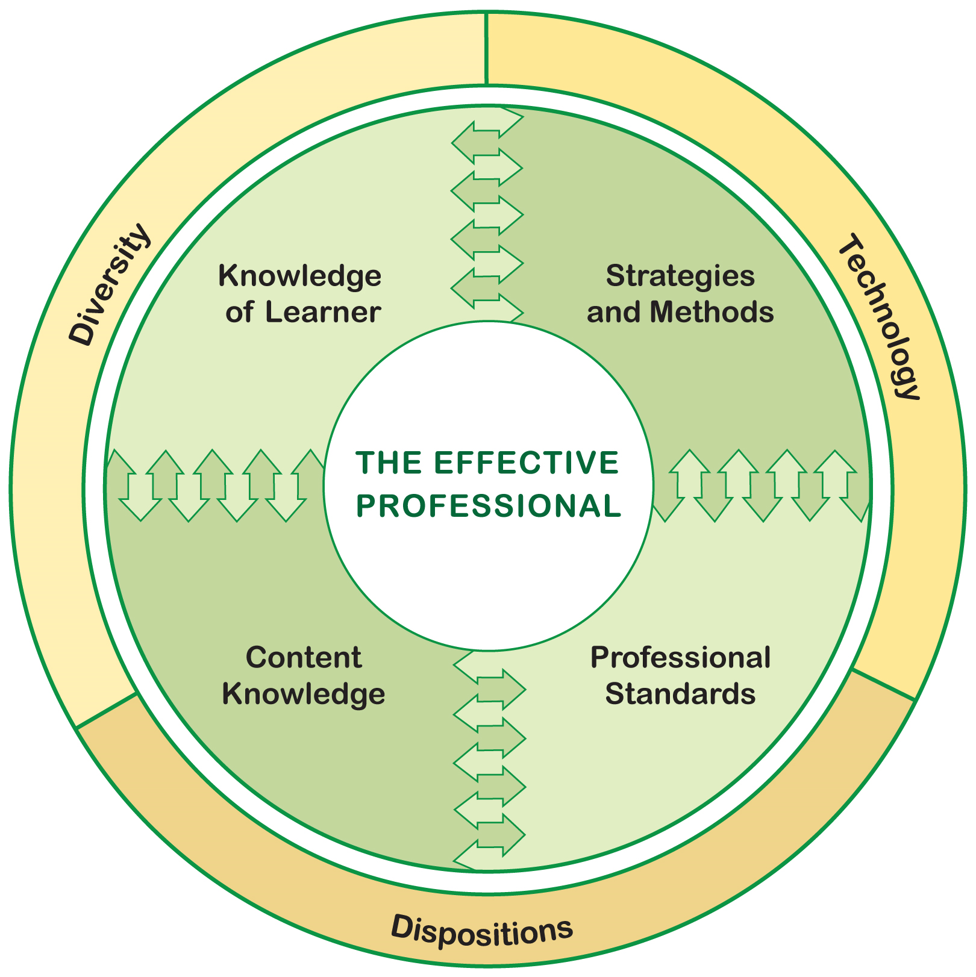

AGENDA

Program Advisory Council

