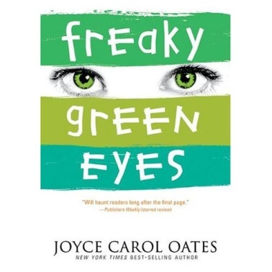
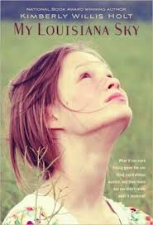
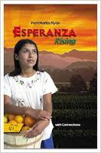
English 426/526
The Adolescent Experience in Literature
Do you want to know what is new in the world of
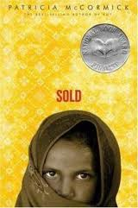
Young Adult Literature?
Then sign up for English 426/526 in Spring 2018.
Mondays and Wednesdays from 2:00 till 3:15 p.m.
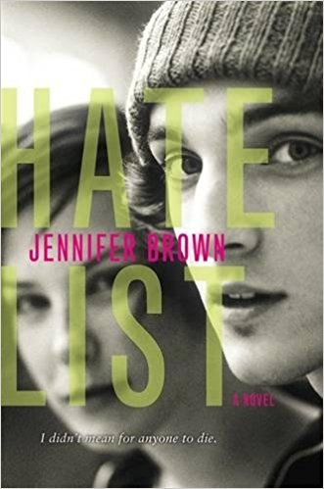
We will explore the role of realistic young adult fiction in the secondary curriculum. How do we connect Young Adult Literature and classics? How do we engage reluctant readers and raise lifelong readers?
