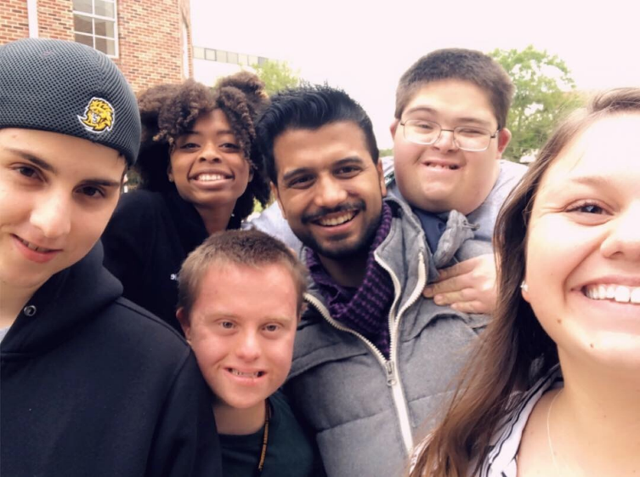
LA-PIE
Louisiana
Post-Secondary
Inclusive Education
Alliance

…Mission is to increase post-secondary inclusive opportunities for individuals with intellectual and developmental disabilities in Louisiana
For more information on starting a program on your campus or alma mater contact us:
LAPIEalliance@selu.edu
Dr. Gerlinde Beckers
985-549-3030
@LAPIEAlliance

