How to access Program Assessment Seminars via Magna Campus in Moodle?
Topics include:
- Undocumented Students: What You Need to Know Now
- Evaluating Your Institution’s Assessment of Student Learning
- Keys to a Culture of Assessment: Value & Respect
- Summarizing and Using Assessment Results
- Moving Ahead with Learning Assessment
- How Good Is Good Enough?: Setting Benchmarks or Standards
- Five Keys: Engaging Faculty in Learning Outcomes Assessment
- How to Evaluate the Impact of Faculty Development Programs
- Connect Learning Across Courses with Curriculum Mapping
- Getting Started with Assessing Institutional Effectiveness
- 5 Steps to Renew Program-Level Learning Outcomes Assessment

Step 1: Log in to Moodle. Make sure the academic year is set for “ALL” then choose the course for Center for Faculty Excellence. 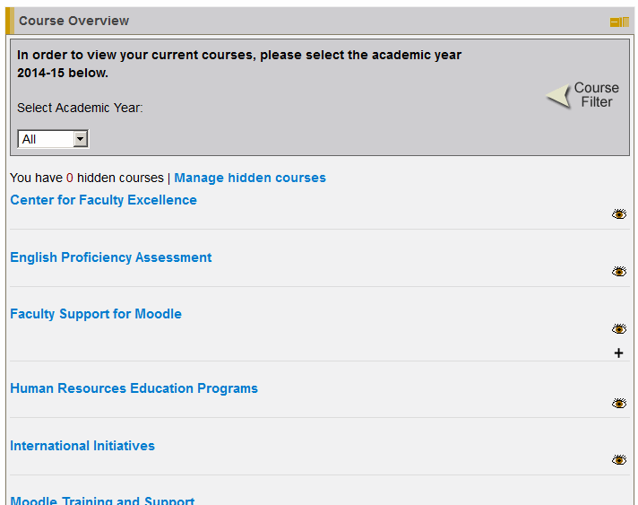
Click Here
Should be set to All

Step 2: Read 1-3 below and then Click on Magna Campus.
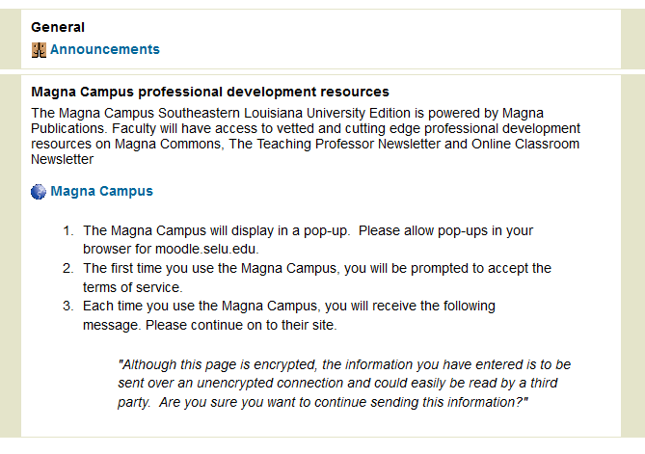
Click Here after reading instructions 1-3
Please note instructions here!!

Step 3. Click on Magna Commons Online Seminars.
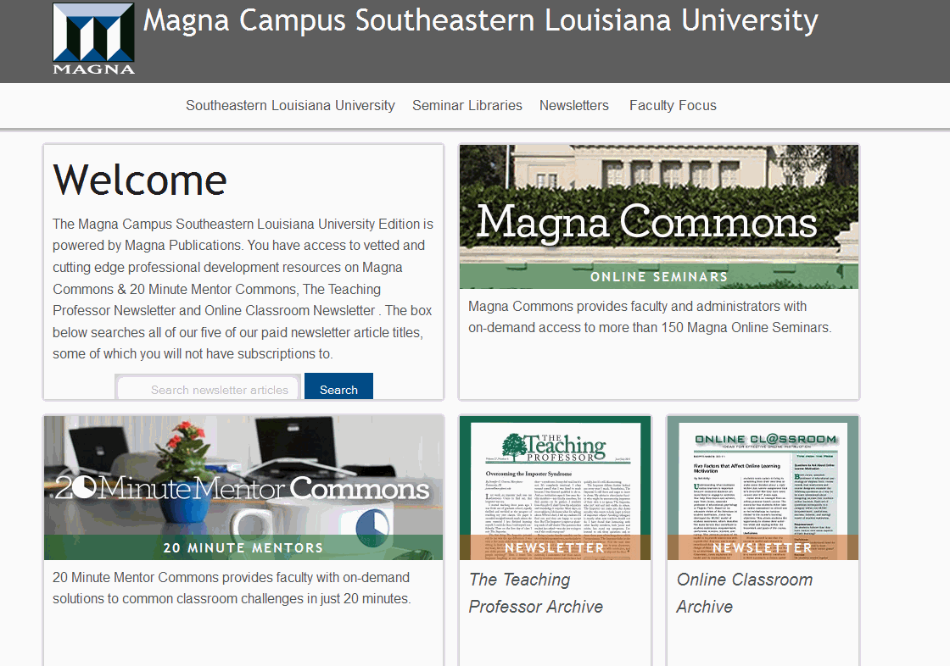
Click Here
Step 4: Click on Academic Administration, then Program Assessment, then choose topic you would like to view.
Choose and click topic third.
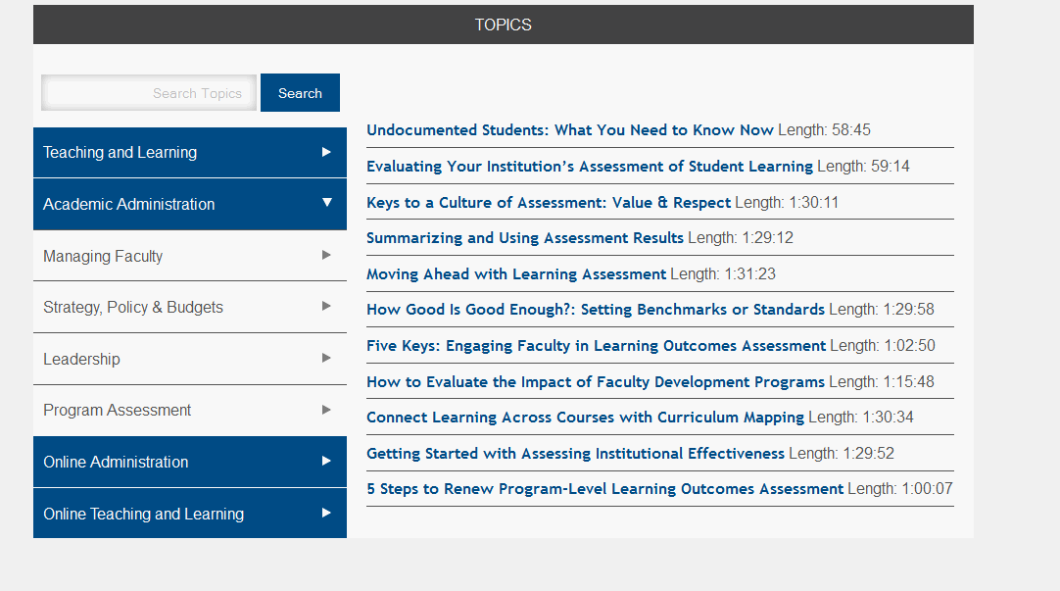
Click here second
Click here first
You can also explore 20- Minute Mentors Commons from the main Magna Campus page.
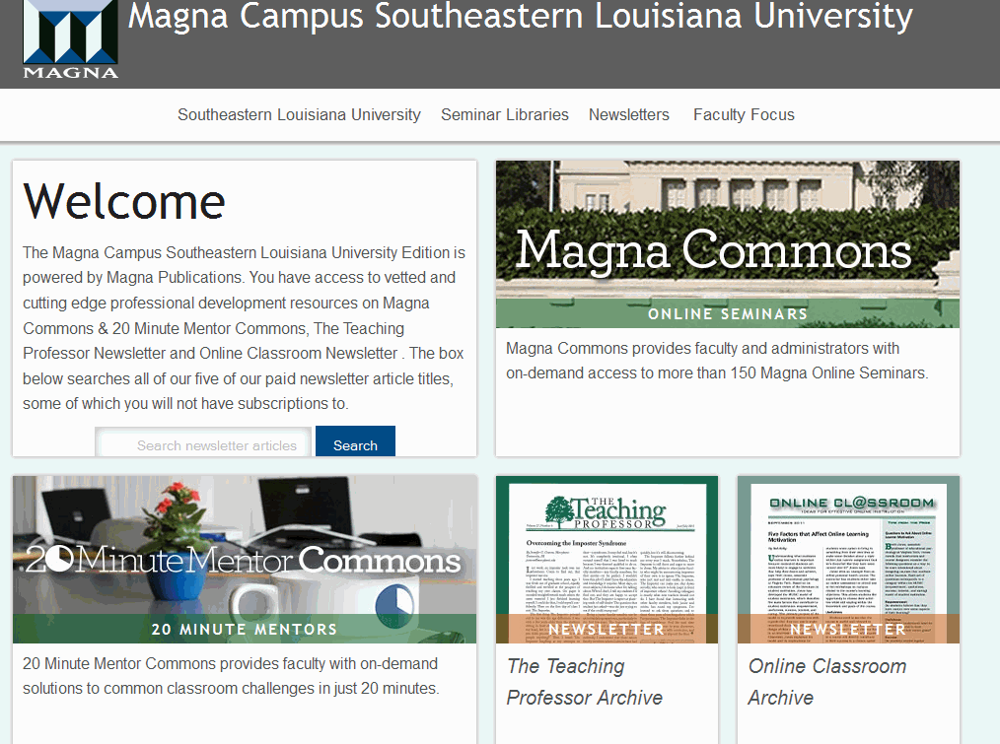
Click Here.

