How To Enroll Into Military Science Classes
Login to Leonet
Click “Enroll”
Next click “Search”
In the subject line look up “Military Science”
Leave the course number blank and hit “Search”
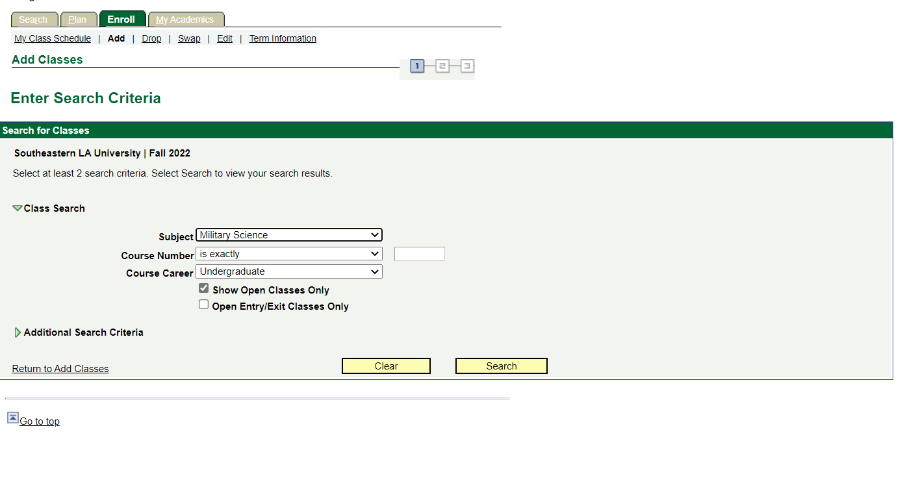

Next Select both the class and the lab
For example, Freshman enrolling for the Fall would be 111&112
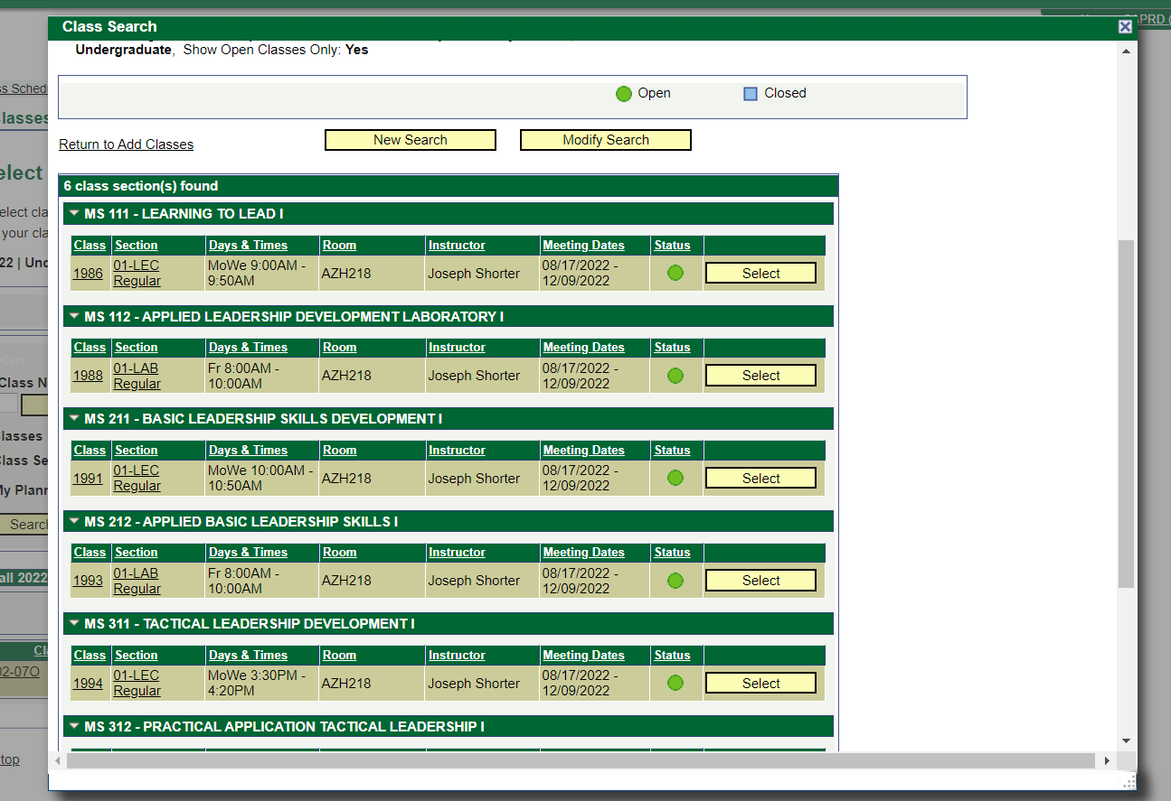
BOTH classes must be in your cart so you can simultaneously enroll
Click “Proceed to Step 2 of 3”
Click “Finish Enrolling”
You should then see a green check mark by the classes.
If you have any problems please contact the office
Military Science Classes
Freshman
111 Learning to Lead I
112 Applied Leadership Development Laboratory I
113 Learning to Lead II
114 Applied Leadership Development Laboratory II
Sophomore
211 Basic Leadership Skills Development I
212 Applied Basic Leadership Skills I
213 Basic Leadership Skills Development II
214 Basic Leadership Skills II
Junior
311 Tactical Leadership Development I
312 Practical Application of Tactical Leadership I
313 Tactical Leadership Development II
314 Practical Application of Tactical Leadership II
Senior (through Southern University)
Theory and Dynamics: Discusses staff organization, functions, and processes, analyzes counseling responsibilities and methods, examines principles of subordinate motivation and organizational change, and the application of leadership and problem solving principles to a complex case study/ simulation.
Senior Seminar in Leadership/management: Discusses legal aspects of decision making and leadership, analyzes Army organizations for operations from the tactical to strategic level, assesses administrative and logistics management functions, discusses reporting and permanent change of station (PCS) process, performance of platoon leader actions, and examines leader responsibilities that foster an ethical command climate.
Leadership Laboratory: Practical exercises in staff organization, functions, and processes, analyzes counseling responsibilities and methods, examines principles of subordinate motivation and organizational change, and the application of leadership and problem solving principles to a complex case study/simulation.
Leadership Laboratory: Provides cadets the opportunity to apply principles and techniques learned in MILS 410.

