Safe Driver Program
Use a computer with printer attached as you MUST print your certificate upon completion of the course.
It is best to use “Mozilla Firefox” or “Google Chrome” to access the course.
- Turn off your Pop-up blockers including any Pop-up blockers on installed Toolbars.
- Read the Safe Driver Policy.
- Complete the course (takes 10-15 minutes) and print your certificate.
- If the Certificate does not load, DO NOT close the browser, see below for instructions on how to unblock the page.

FIREFOX BROWSER: Click on the LOCK to the left of the address bar.
It will state “Firefox has blocked parts of this page that are not secure.”
Click the arrow, then click on “Disable protection for now”.

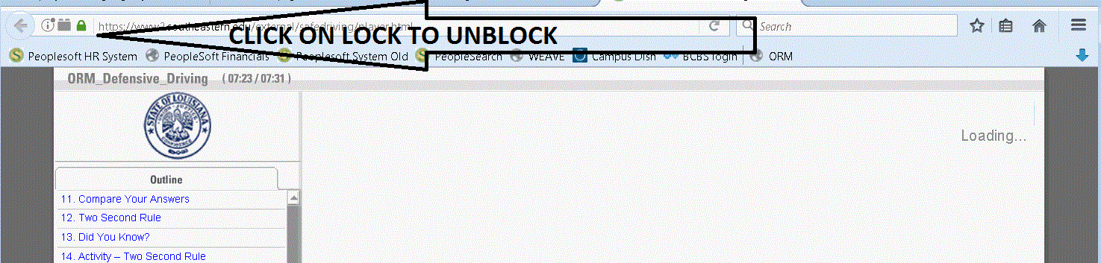

GOOGLE CHROME BROWSER: Click on the SHIELD on the right of the address bar.
Then click on “Load unsafe scripts”.

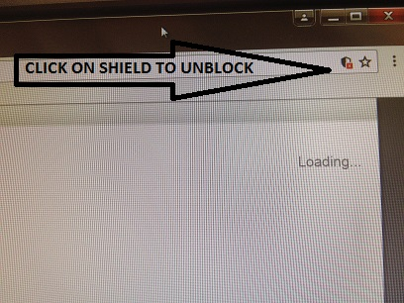

- Access the On-line Driving Course: Safe Driver Course
http://wwwprd.doa.louisiana.gov/orm/Online_Courses/Defensive_Driving_313/player.html
- Complete, initial and sign the Driver Authorization Form (DA2054 form). Just completing the course online will not give you authorization to drive on University-related business.
You MUST send the certificate and the completed Driver Authorization Form to:
Environmental Health & Safety Office - SLU 10452
- You will only be contacted if a non-valid ODR is received - to clear up any discrepancies before authorization can proceed.
- **IF YOU HAVE AN OUT-OF-STATE DRIVERS LICENSE, you must provide the Environmental Health & Safety Office with a copy of your Official Driving Record (ODR). You may obtain a copy of that record from the Department of Motor Vehicles in the state where you received your license. Certification cannot be granted until your valid ODR is received.
Rev. 12/6/17
State of Louisiana
DRIVER AUTHORIZATION FORM
TO BE COMPLETED ANNUALLY, UPON CHANGE OF STATE OF ISSUANCE, CLASS OF LICENSE, AND/OR DRIVING RESTRICTION CHANGE

Employee Name: W Number:
Agency: Southeastern Louisiana University Immediate Supervisor:

Job Title: Office Phone:
Drivers License Number: Class License:

State of Issuance: Expiration Date:

EMPLOYEE ACKNOWLEDGEMENT/AUTHORIZATION

This is to certify that as a condition of and if authorized to drive my personal vehicle on state business, I have and will maintain at least the minimum liability coverage as required by LA. R.S. 32:900 (B) (2).

I understand that the use of my vehicle on state business requires prior written authorization from my supervisor or agency head.

Further, by signing this document, I agree to notify my agency in writing should any of the following change on my license: Drivers License No., State of Issuance, Class of License or Driving Restrictions.

I authorize my agency to obtain access to my Official Driving Record (ODR) as necessary to comply with the State’s Loss Prevention Program.

I affirmatively acknowledge and understand that operating a state-owned, state-rented or state-leased vehicle while intoxicated as set forth in R.S. 14:98 and 14:98.1 is strictly prohibited, unauthorized, and expressly violates both the terms and conditions of my use of said vehicle, and my employer’s instructions. In the event such operation results in my being convicted of, pleading nolo contendere to, or pleading guilty to, driving while intoxicated under R.S. 14:98 or 14:98.1, I acknowledge and understand that such would constitute evidence of: (1) my violating the terms and conditions of my use of said vehicle, (2) my violating the direction of my employer, and (3) my acting beyond the course and scope of my employment with the State of Louisiana. I further affirmatively acknowledge and understand that personal use of a state-owned, state-rented or state-leased vehicle is not permitted.

My signature on this document shall remain in effect until revoked by the agency or until a new form is executed.

_______ (Initial) I have read and understand the Safe Driver Program Policy.

_______________________________ __________________________
Employee Signature Date

THIS SECTION FOR ENVIRONMENTAL HEALTH & SAFETY OFFICE USE ONLY:
AGENCY HEAD OR DESIGNEE AUTHORIZATION

By executing this document, I have reviewed the Official Driving Record and Driver Training Course dates and have confirmed the information to be current and in accordance with the ORM Loss Prevention requirements.

My signature authorizes the aforementioned employee to drive the following on state business as required (check all that apply):

_______ STATE VEHICLE
_______ RENTAL VEHICLE
_______ PERSONAL VEHICLE (The “Private Vehicle Insurance Declaration” must be signed prior to Authorization).

Date of last Driver Training Course: Month ________ Day ________ Year ________

__________________________________ _________________________
Agency Head (or designated individual) Date of Authorization

4/3/17
DA 2054

