English 489/589
Postmodern and Contemporary Literature
The Magic of Life and Death

Fall 2016
TTH 11-12:15
Dr. R. Bouton

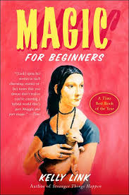

Tentative Reading List:
A Thousand Splendid Suns-Housseini
The Brief and Wondrous Life of Oscar Wao-Junot Diaz
The Shipping News-Annie Proulx
White Teeth-Zadie Smith
Runaway-Alice Munro
Magic for Beginners-Kelli Link
Just Kids-Patti Smith

