“Hemingway and His Contemporaries”
English 491/591: Major American Authors

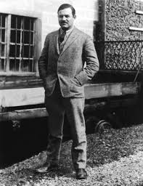

Spring 2022
Dr. Richard Louth
rlouth@selu.edu

Tues./Thurs. at 2:00-3:15

Hemingway: Contemporaries:
In Our Time Sherwood Anderson
The Sun Also Rises F. Scott Fitzgerald
A Moveable Feast William Faulkner
A Farewell to Arms John Dos Passos
For Whom the Bell Tolls
The Old Man and the Sea
The Garden of Eden
The Snows of Kilimanjaro and Other Stories

