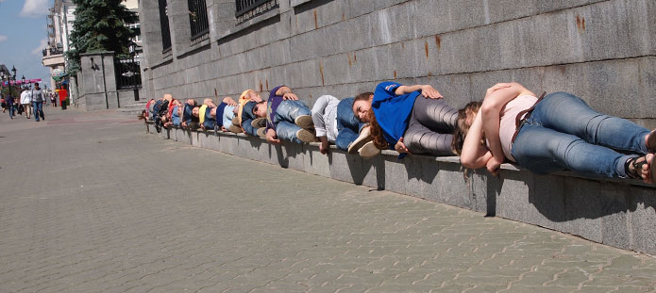

English 610: Studies in Performance
Performing Politics: Theory, Practice, Narrative
Spring 2016

Dr. Jayetta Slawson

Wednesday, 5:00 to 7:45 p.m. Class 2728

The interdisciplinary field of Performance Studies moves freely between the theatrical stage and real life. This class embraces theory, practice, and creative writing processes while interrogating the role of political performance as an instrument of rebellion, suppression, and narrative.

